Handling Debt in Prison Guidelines for Centres
CMA is now expanding its outreach into supporting prisoners with debt issues, which is a major topic that is not adequately addressed by the Prison Service. There is also a lack of coordinated material to support prisoners, their families or prison staff from what we understand.
It should be stressed that this support is for external prison debt and not for internal prison debt which is a separate problem.
The first challenge is to identify the department or person responsible for helping prisoners with their debts and to work with them on defining the process for working with you. This will vary from prison to prison.
As a result of various activities to promote CMA in prisons, you may be contacted by your local prison for assistance if you are not already working with them. Typically, an enquiry will be made by a prison officer/support worker rather than from the prisoner directly as contact from inside prison is restricted. The first step is to forward a copy of the CMA Handling Debt While in Prison booklet.
It is recommended to have an enquiry form, as in the example below, that the prisoner completes which the officer can scan and email as post is terribly slow in the prison network and not always guaranteed to make it. It is always better to work with an officer (or relative) rather than the prisoner directly as communication should be much faster and they can help explain the situation.
Unfortunately most forms are never complete with all the information you require as they do not always have the address or account details of the creditor. This is why it is better to work through an officer so they can clean up the information you need before forwarding. Also, some prisoners cannot read or write so this will need to be taken into account. Face to face meetings are possible however it is better to gather as much information as possible beforehand.
The forms should include date of incarceration and release so that any debts that may become statute barred are identified plus if the release date is withing six months you will need to consider if the issues are resolvable within this timeframe as the prisoner may move away to a different area resulting in contact issues.
Depending on the literacy skills of the prisoner it is good to encourage them to manage the process as much as possible themselves with support from you when necessary. Customised letter templates should be made available to relevant prison staff together with a Financial Statement spreadsheet.
For new prisoners, the priority is to write to all creditors and freeze the debts due to their situation. It would be good to get authorisation for a partner/relative to represent them as contact would be much easier. One challenge is that prisoners tend to be moved after a few weeks after imprisonment to more permanent facilities and letters are not always forwarded to their new “residence”. Prisoners start to take their debt seriously as the date of release draws near and, in many instances, it would be better to get them to work with their local CMA Centre after release as access to documents should be much easier. Depending on the type of offence some prisoners on release may not be allowed access to the internet so this needs to be taken into consideration.
If you need any help or have any questions then my contact details are info@communitymoneyadvice.com,
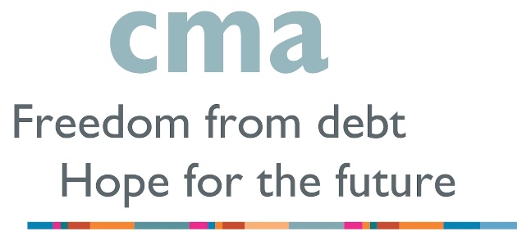

Client Information Form
CONFIDENTIAL

CLIENT FULL NAME:
Other names known by:
Gender, Date & Place of Birth:
NI Number:
Marital Status:
Current Address: | HMP ……………………………………………….
Prisoner Number:
Date of imprisonment:
Likely date of release:
Addresses (last 6 years)
start & leaving date for each:
Do you own or rent the accommodation lived in prior to imprisonment?
Are you named on the deeds of any other property?
Do you have a bank account? If yes, is it a joint account?
Do you have any current income or savings?
Do you have any other assets in your name (e.g. a vehicle)
Do you have a Legal Aid debt?
DEBTS:
Name and address of creditor | Type of debt  (e.g. loan; credit card; council tax) | Amount owed | Reference and address debt is linked to.

Are all the debts above in your name alone or are some joint debts?

Any other relevant information?

Signed ___________________________

Printed Name ___________________________

Date ___________________________

Letter of Authorisation

To whom it may concern

is assisting me with my financial affairs and I hereby authorise you to divulge details of my financial situation to them and to negotiate with them accordingly.

Name
Address HMP
Post Code

Date of Birth

Signature

Date

HMP

Date
Creditor Address

Your Ref:
Account Number:
Re
Dear Sirs
I am writing to you to let you know that I am presently experiencing financial problems and need to understand my current situation with you. I am presently in Littlehey prison and expect to be released in
I would be grateful if you would supply details of any outstanding balances together with the current contractual repayment amount and the total of any arrears. Please also supply information relating to any planned enforcement action. I am contacting all my creditors and as you appreciate, the collection of information is likely to take some time and I therefore request that whilst I am making enquiries you take no further enforcement action and freeze any interest and charges that may be accruing. Please place a hold on this account for a period of 60 days to allow me to gather the required information.
I look forward to your early response and I thank you for your assistance in this matter. Once I have heard from all my creditors I will write to you again.

Yours faithfully
HMP

Date

Creditor Address

Your Ref:
Account Number:
Re
Dear Sirs
Thank you for your letter dated providing me with details of my account with you. I have now received all the information from my other creditors and as you can see from the enclosed financial statement, I am in no position to make a full repayment. I am presently in prison and as a consequence I have no disposable income to distribute to my creditors.
I would therefore ask that you place a moratorium on this account until I am in a position to start payments once my situation improves.
I will contact you again as soon as there are any changes in my circumstances, and I thank you for your assistance in this matter.

Yours faithfully

HMP

Date

Creditor Address

Your Ref:
Account Number:
Re
Dear Sirs
Thank you for your letter dated providing me with details of my account with you. I have now received all the information from my other creditors and as you can see from the enclosed financial statement, I am in no position to make a full repayment. I am presently in prison and as a consequence I have minimal disposable income to distribute to my creditors.
I would therefore ask that you accept a token payment of £ per month on this account until my situation improves.
I will contact you again as soon as there are any changes in my circumstances, and I thank you for your assistance in this matter.

Yours faithfully

